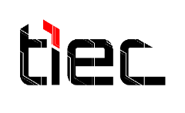
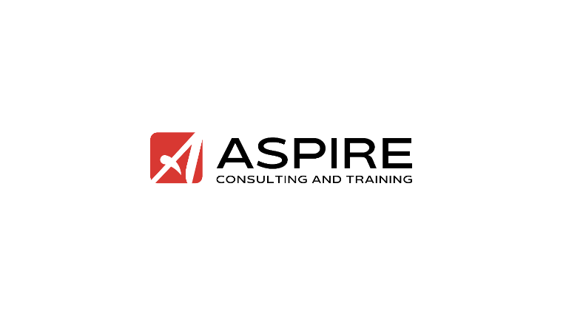

TIEC-InnovEgypt Program
Prototype Links Template

Prototype Links Template

Links

Storyboard (if physical product):

Website or Mobile App Demo (Marvel App) (if virtual product):

Landing Page: (OPTIONAL)

